# :<h1 class="display-2">{{r.recipeName}}</h1>מצרכים:<br><div id="products"><br>

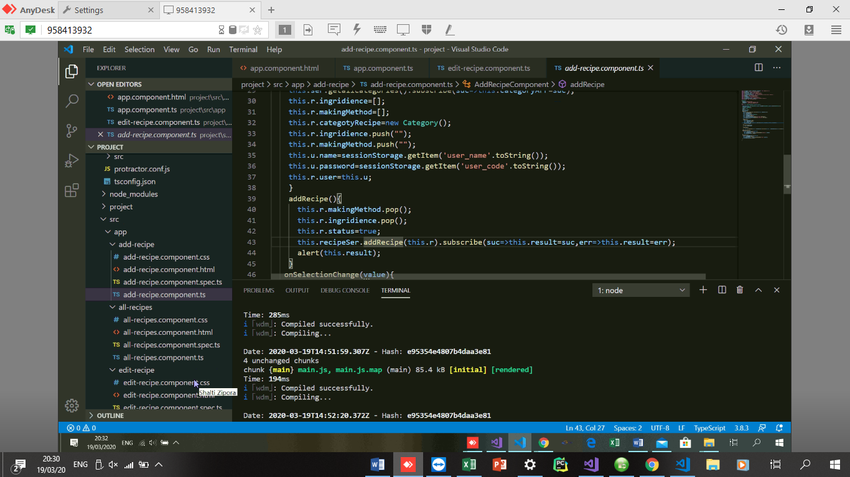

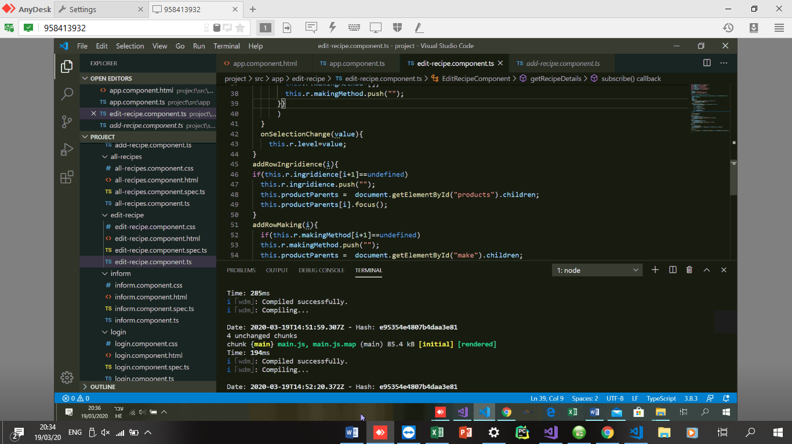

<input *ngFor="let x of r.ingridience;let i=index" type="text" [(ngModel)]="r.ingridience[i]" (change)="addRowIngridience(i)"><br>

</div><br>

הוראות הכנה:<div id="make">

<input type="text" *ngFor="let x of r.makingMethod;let i=index" [(ngModel)]="r.makingMethod[i]" (change)="addRowMaking(i)"><br>מצרכים:<br><div id="products"><br>

<input *ngFor="let x of r.ingridience;let i=index" type="text" [(ngModel)]="r.ingridience[i]" (change)="addRowIngridience(i)"><br>

</div><br>

הוראות הכנה:<div id="make">

<input type="text" *ngFor="let x of r.makingMethod;let i=index" [(ngModel)]="r.makingMethod[i]" (change)="addRowMaking(i)"><br>